Research Daily Journal – Anuar Santoyo

2023.02.15

I read the Master Thesis “Mechanical Design and Aerodynamic Evaluation of a Bio-inspired Morphing Wing” from Luca to get an idea of what a good thesis looks like and started reading DR Sudeep Dissertation “Kinematic Analysis of a Bat Flight Based on Membrane Wing Motion Reconstruction”. I also started researching on papers regarding training robots with reinforcement learning.

Todos:
- Read Dr. Sudeep Dissertation

2023.02.16

Kept reading Dr. Sudeeps dissertation, and added some questions. Proposed paper idea (AAAAa le mamó!!) started working on sketches ideas.

Todos:
-Read Dr Sudeeps dis and make questions quote – “the more the better”

2023.02.17-2023.02.19

Finished reading Dr. Sudeeps dissertation and wrote down questions. Had meeting with Dr. Sudeep, questions were answered. Thought of way of achieving dynamic hovering testbench.

2023.02.20

Prepared Presentation of thesis proposal idea with static and dynamic tests. Found papers on reinforcement learning in flying machines.

TODO:
- Learn more about controlling
- Focus on application of ML on controlling optimization

2023.02.21

Watched several videos regarding control theory, as well as a series from mathlab to control drones. Read papers that use genetic algorithms to optimize PID controllers. Watched a bunch of videos of flapping robots

TODO:
- Improve presentation

2023.02.22

Gave presentation, had good feedback. Conclusion was to focus on developing the static test first and whilst doing so keep an eye open for useful things for the dynamic test. My actual plan is to read as many papers regarding controlling, genetic algortihm and flapping robots to migrate from a naive idea to a mature one. Hopefully I will soon have the chance to interact more with the robot to gain more insight in its dynamics. I opened many papers that might be interesting.

TODO:
- organize computer and papers

2023.02.24

PID seem to be widely used in drones. RL might be out of scope as it need many repetitions usually achieved with a simulation environment. We try to prove that GA tackles this issue directly in the real world.

Some summaries of interesting papers:

data_driven_insects.pdf:
references CMA. also uses 2 steps GA, uses real ant data as part of the score in GA, one layered NN optimized with GA. THEY ALSO USE CMA!!! and explain it. They use simulations :/ (Simulation framework: Bullet). Question, can it be applied in real world? They used a lot of parameters (Stage I 198, Stage II 608), we might need far less. Conclusion: Exiting to see they use same basic ideas(2 Stages and CMA), unfortunately they apply in simulation, but on the other hand they optimize in very high dimensions and we don’t. Might be useful for initial hyper-parameters, and as inspiration to use real bat data.

dc_motor_pid_ga.pdf
Explains traditional method of tuning PID and compares it with better performing GA optimization. Clear description of GA hyper-parameters.

pid_ga.pdf
most populat controles pid, clear advantages of GA are described.

bird_control_ml.pdf
Talks about the difficulty of simulating airflow in mid Reynolds numbers and the computation expenses of it. ML and data driven might be better to finding approximate models compared to only physics.

flapping_bird_controll.pdf
Advantages of flapping robots is described. Mass and inertia of wings cannot be neglected (advantage for us as the mass of wings is very low). 500Hz control frequenc using FreeRTOS. They analyze force and moment produced by wings and tail separately. For control combination of fuzzy and pdi. They use averages for a whole flap cycle (divided in upstroke and downstroke). Use interesting fixed to a moving mechanism for test (good for our dynamical test). Extensibly explains hardware used, including sensors. Baromeneter MS5611 used with 10cm precision.

flapping_model.pdf
Mostly deep aerodynamics explanations and analysis. Mentions that elastic wing flapping is largely unexplored. Intereseting figure showing hovering aerodynamic from a hummingbird. Too aerodynamical. Use similar structure as the one planned for the static test. Ussing only one Ft Nano-25 force sensor.

hovering_flapping_controll.pdf
Hovering strategy by changing wing flap velocity.

model_flapping_robot.pdf
Reference papers that achived hovering for flapping wings. Mentions that most flapping control is based on wing frequency and mean angle of attack (interesting, the fact that they use mean angle of attack can be useful). Used simulations

mechanism_flapping_vehicle.pdf
Very straight forward explanation of design of flapping bird.

summary_robot_rl.pdf
DRL often needs tens of millions of data samples to learn meaningful locomotion gaits. Robot safety is a bottleneck. In Summary, we can forget about RL (question arises, even for such a small dimension as ours)

Links
Control Theory tutorials
https://engineeringmedia.com/videos
Best controlers
https://robocraze.com/blogs/post/best-flight-controller-for-drone
RaspPi Controller
https://www.unmannedsystemstechnology.com/2022/06/raspberry-pi-based-flight-controller-os-for-rovs-and-robotics/
ESP8266 drone tutorial
https://www.instructables.com/Build-Drone-With-ESP8266/

All to the day pending papers were read and summarized. Started hardware selection investigation.

Created Hardware Selection file. Until now, NodeMCU with arduino and pyhton communication look promising. Need to check if NodeMCU is powerful enough for flight control.

TODO:
-find more applications of CMA
- Ask Dr. Sudeep for BCS data
- check nodemcu

2023.02.25

Quickly checked accuracy of barometers (around 15cm, good enough). Decided to use ESP8266 and python and saw couple of tutorial regarding connection. Actual main idea, use NodeMCU with accelerometer/gyro module and barometer as sensors. Apparently Dr. Li is working on static bench design (from the mechanical part) so I will focus on the software part.

TODO:
-Buy:
-NodeMCU 2021
-MPU-6050 IMU (accelerometer/gyro)
-Grove - High Precision Barometric Pressure Sensor (DPS310) Acc 2cm

2023.02.27

Ordered ESP8266, arrives in 2 days. Meanwhile preparing computer using https://www.instructables.com/ESP8266-and-Python-Communication-ForNoobs/.
Started to look for options to connect pressure sensors from Dr. Lis test idea. RaspberryPI has no analog input, arduino does.

https://realpython.com/arduino-python/ used to connect sensors to python using an arduino uno

Update: using tutorial from https://www.learnrobotics.org/blog/arduino-data-logger-csv/ to connect sensor_arduino with python we better read the data from within arduino printed in the serial monitor and from there obtain the data for python. The last idea was to use a loop from python to call the data from the arduino using framatta. Bad idea as python takes a little delay with each reading and they accumulate throught time.

2023.02.28

Using https://www.learnrobotics.org/blog/arduino-data-logger-csv/ idea I created a first working prototype of communications between pyhton and arduino. Can be seen in sensor_arduino.ino and ardunio_serial_sensor.ipynb. Started the first draft of the whole framework and included place holding functions.

2023.03.01

Managed to successfully read data from the GY-85 9DOF IMU Sensor Module using IMUGY85.h module. Able to send data collection command from python to sensor and retrieve data in pyhton and plot. Program is ready to be tested. Python commands measurements and they are gotten from the ugy 85, constructed first test bench for prove of concept.

Prove of concept consists in a servo connected to an accelerometer. As the servo moves, the sensor measures the changing strength of gravity with respect to one axis. The servo is commanded to move in a sinoidal way, the parameters of the trayectory are the amplitude and frequncy of the sine. The idea is to use the constructed framework to see through iterations the servo can find the correct amplitude and frequency to imitate an arbitrarily given sine function.

Spend a lot of time trying to make rest of microcontrollers work.

TODO:
- See if you can make servo run on any microcontroller (until now only one works and they have to be different as sensor and motor must work in parallel)
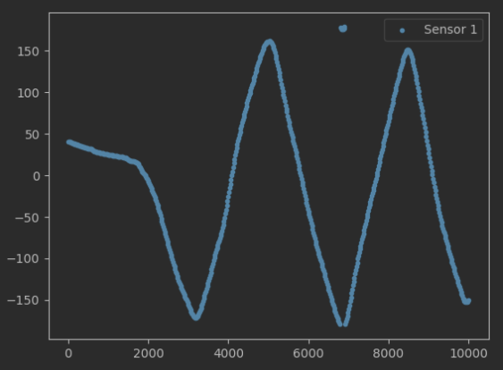

2023.03.02

Today was a good day, finally made ends meet. The ESP8266 arrived and I was able to connect it and control it using https://randomnerdtutorials.com/esp8266-web-server/ and passing instructions as a html request. Started testing the simultaneous command and sensor and it works, unfortunately the sensor is not working as expected, giving funny signals even when static. That is why the next steps are to fix or find a better sensor reading. Second issue is that the way I am currently controlling the servo creates a zig zag more than a sin function, I believe a sin function is better for presentation purposes. Prof. Zhao asked me to make a presentation next Thursday showing my advances and with a more detailed planning on the experiment set up.

TODOS:
- Correct sensor readings
- Correct servos sine function
- Apply on main CMA algorithm and optimize
- Make presentation for it.

2023.03.03

Built prove of concept prototype using a potentiometer. Achieved much more reliable measurements. Worked on the post processing of the raw measurements and on the calculation of the fitness model, also used experimental data to arbitrarily choose a goal sine function that will be used in the tests (amplitude 30, frequency 2). Corrected the servo code and sines are now created instead of zig zags, never the less there appears to be some kind of issue with the connections as the servo sometimes goes unreactive or crazy. Must give another look to obtain constant repeatable tests. Also started working on the visualization of the algorithm for the presentation.

TODOS:
- Repair servo
- Test limit values in frequency to achive larger amount of test domain.
- Create simulation of CMA using sine to choose better hyper parameters to find quicker solution when doing the real test.
- TEST CMA BABY!!!!(:

2023.03.04

Repaired servo problem, when servo starts it requires a lot of energy, when it demands more than what the arduino can provide arduino resets ( or something like that). The solution was to connect the MEGA to the powersocket and feed the the servo power (which is controlled by the ESP) from the MEGA. Also, using direct command to return to base position was demanding. So I implemented a small P control to return to base position.

Extreme values were analyzed. The decision was made to use amplitudes between 0-90 and frequencies between 0-5.

2023.03.05

Sucesfully created CMA simulation to analyze best hyper parameters. I will be using n_pop of 5, sigma and sigma of 1. Started testing whole framework on prototype. Minor bugs were fixed.

2023.03.06

First successful test using whole system!!! (awebo) It optimized beautifully, I worked on better visualizations and plots to understand the process of optimization (took much longer than thought of, specially the pinche ellipse. The ellipse to so long because the optimization domain is between (0,1) and it is then scaled for the commands, to draw the ellipse in the transformed domain took way to long, I read for hours stuff from cov matrix to linear transformation…. At the en decided to do the whole the visualization in the optimization domain and only scaled the labels of the axis (cheating? Yes, but non relevant for a simple presentation :D ) Started preparing presentation for tomorrow.

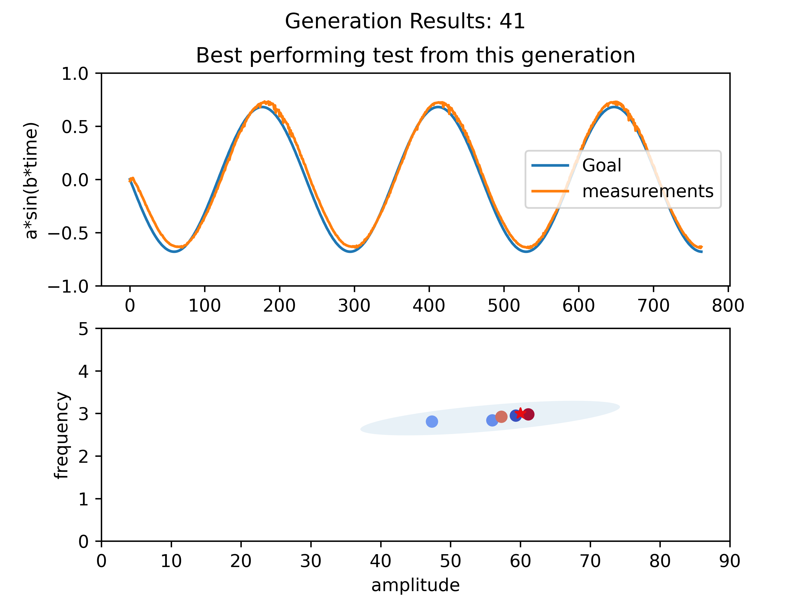

2023.03.07
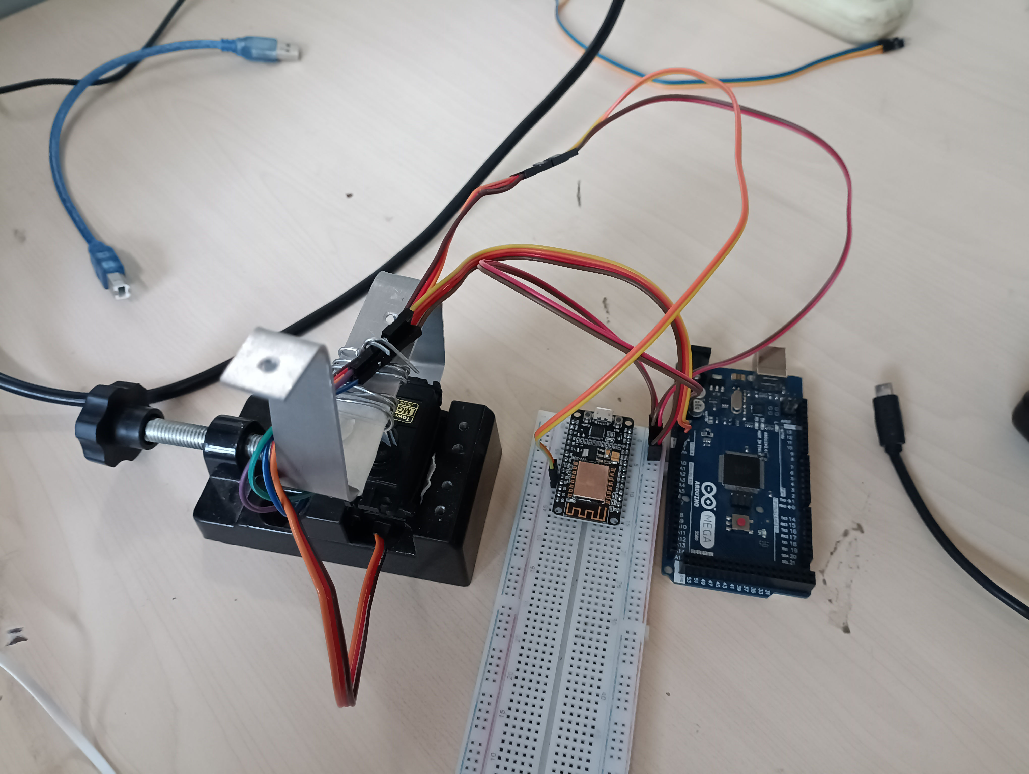

Finished final touches of presentation, created gifs of optimization and improved minor detail. Presented, it was a good presentation. Had very good feedback, to have a running prototype in 2 weeks was found to be “impresive”. Prof. Zhao commented that if whole control loop happens in less that 30 milisecond, that we will have better chances on controlling the batbot. Dr. Li asked question regarding the relationship between amplitude and frequency on my prototype, was not able to explain in detail (not sure if I understood the question completely). Either way, this shows the urgency on understanding the control on the real Batbot (btw.. the name Batbot was also very celebrated and now everybody uses it). 2 important questions rouse from the presentation:

1st : Is the esp8266 powerfull enough? How are microprocessor measured, what is relevant? How does the esp8266 compare to the microprocessor being used at the moment?

2nd : How to control robot? Are we sending sin waves and changing parameters or juat?!?

2023.03.08

Dr. Li gave me the code in C of the robot and explained me that the actual issue is that the servo cannot flap at the same frequency as the wings (5-8Hz). The present goal is to achieve a sinusoidal wave movement of 5hz with an amplitude of 38°. Dr. Li says that when the frequency increases the amplitude changes. I created a simple arduino program to run the test. It looked like it worked but when I showed it to Dr. Li he said that we need to measure the amplitude to see if it actually makes the desired trajectory. He gave me a hall sensor for roation measurements. I spent time trying to find documentation about it.. unsuccessful. So I decided to test it.

2023.03.09
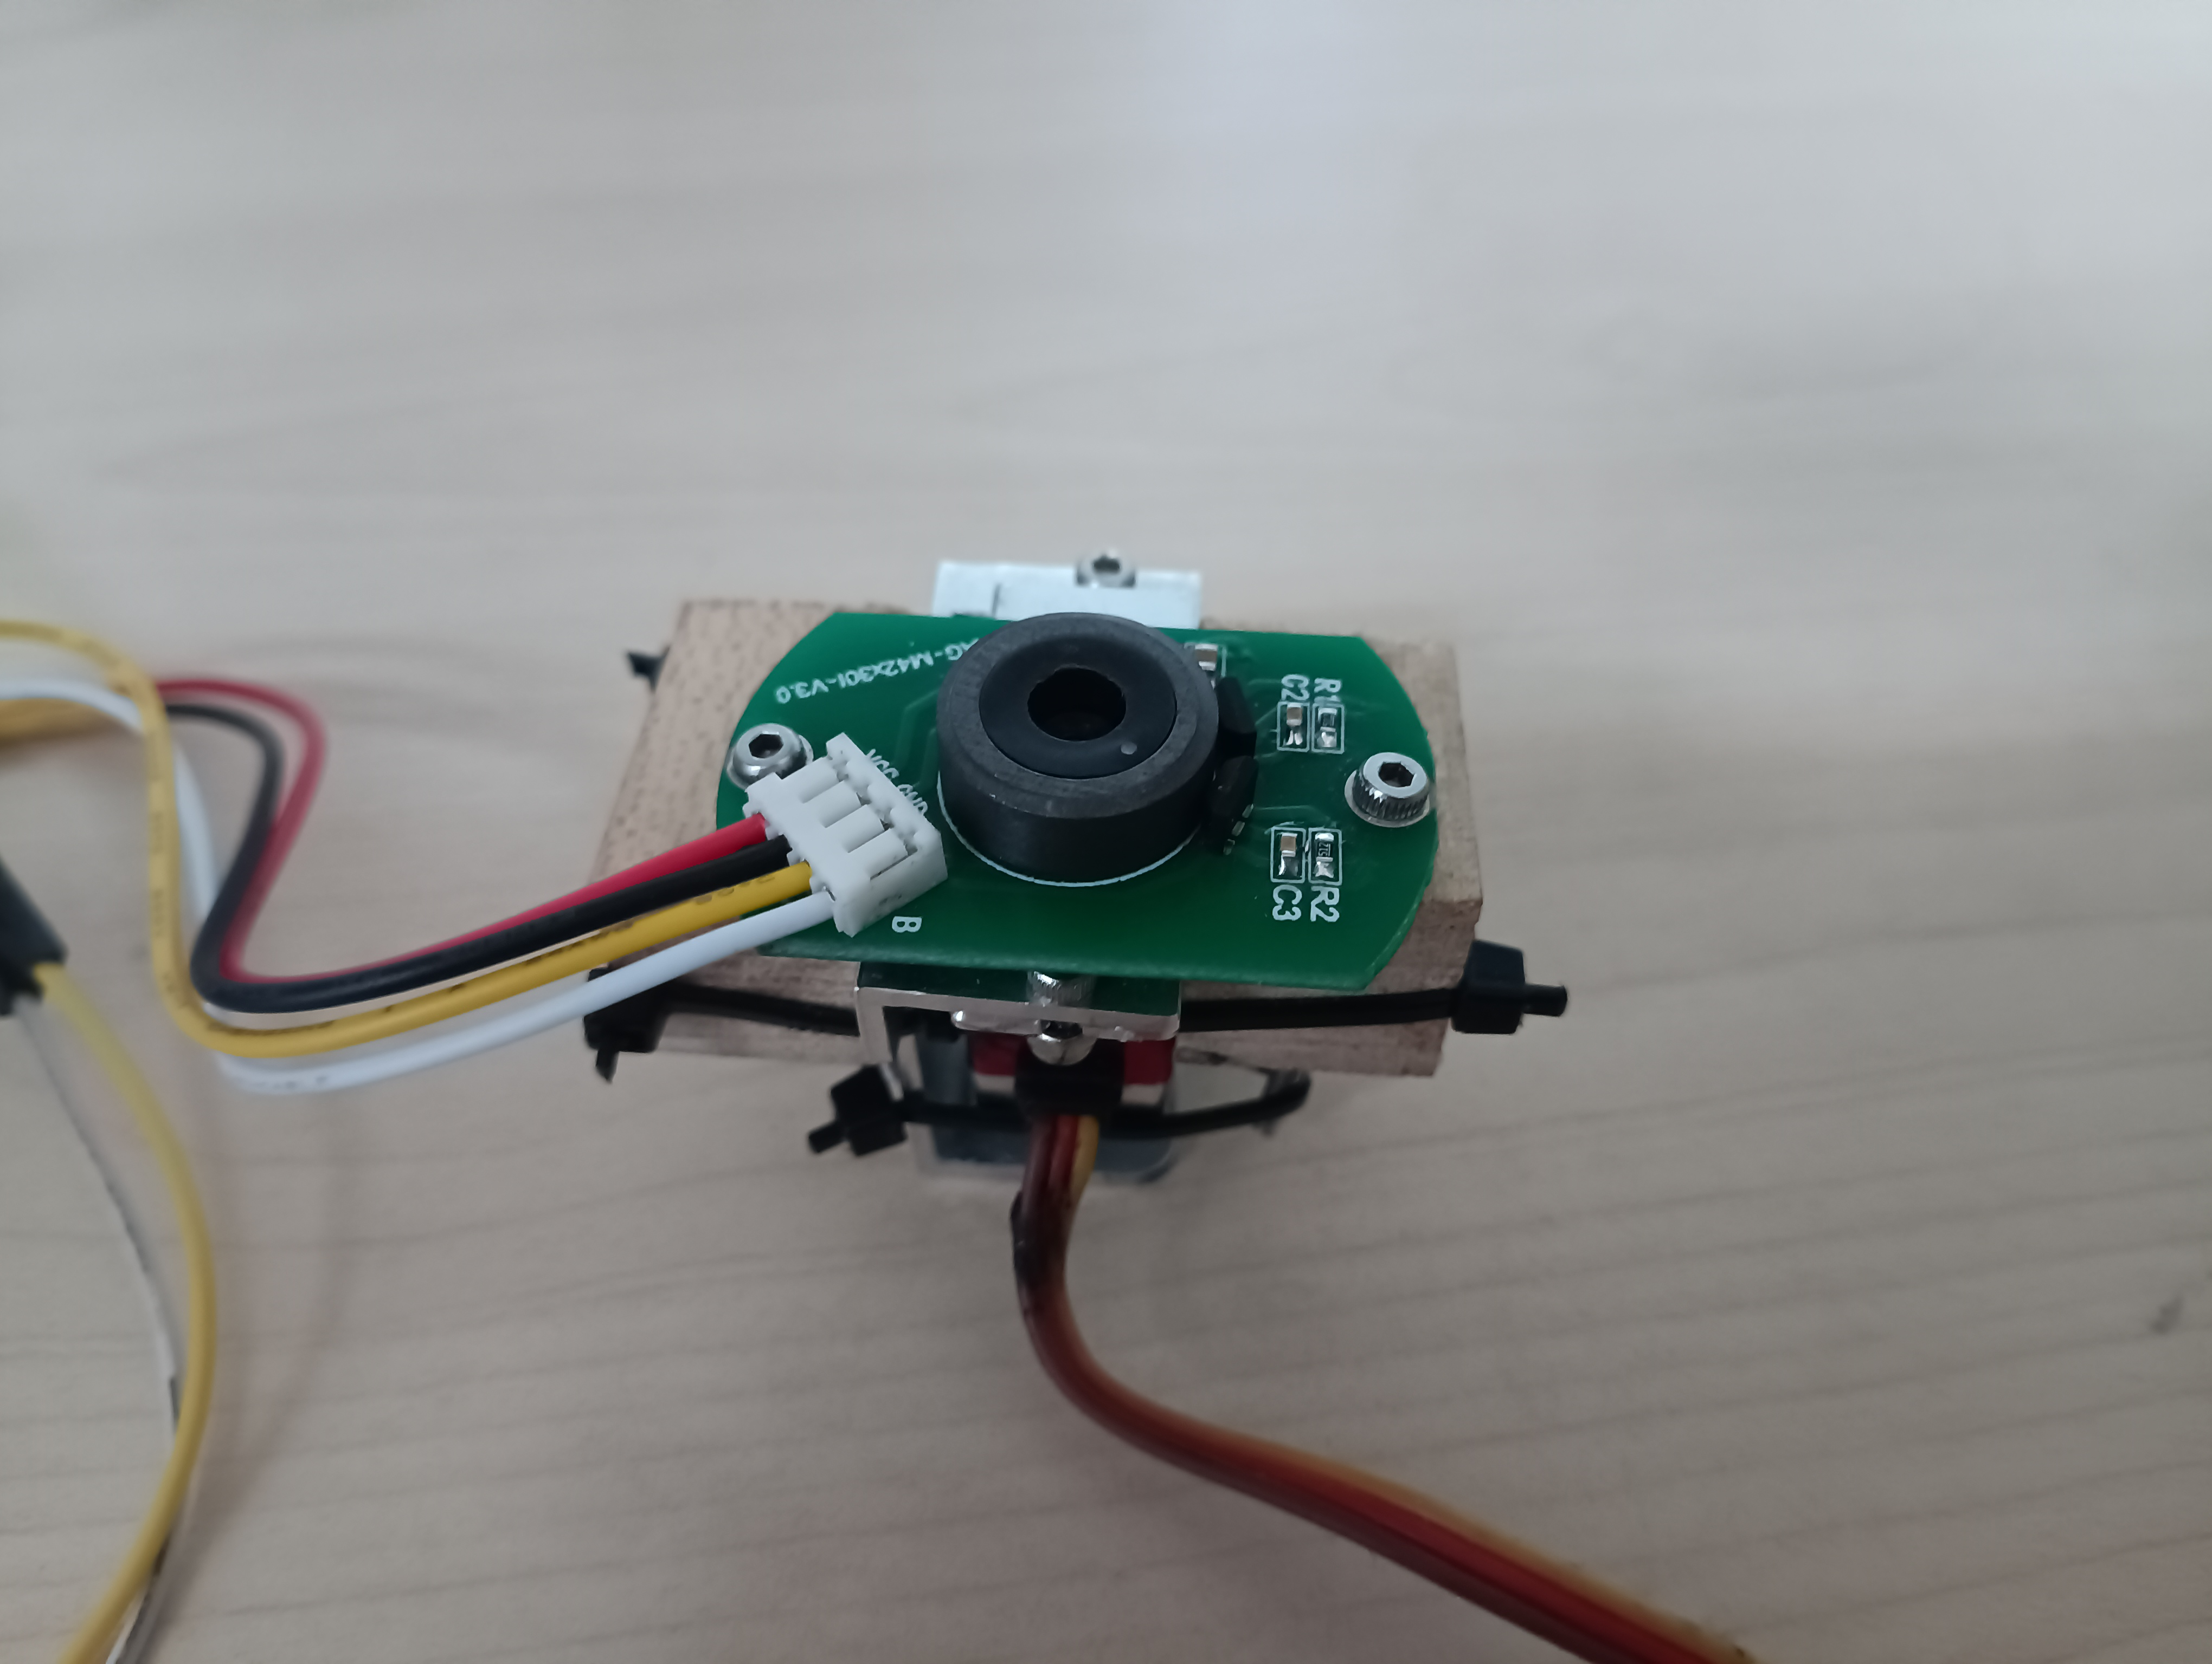

Built with wood and stuff I found in the lab a little test bench for the servo amplitude/measurement (took a while)

Read raw data in Analog and tried to find out how to obtain angle measurement from it. While experimenting… I broke it. Had to wait until Sunday to continue with experiments. :D

2023.03.13

Sensors arrived!! Installed new one. Organized files and created Github Repo. Created framework for testing frequency. 5Hz with 40° amplitude were achieved, we will do tests tomorrow on the real robot to count the friction factor aswell in. IDEA: use second NodeMCU for measurements to send data wirelesly.

2023.03.14

Dr. gave me a DC motor to try to control using the arduino, was straight forwardly achieved. Afterwards Dr. Li gave me a Pixhawk Lite to try to learn how it works. It seams that he prefers to use the Pixhawk over the arduino. I started learning how it works to see of its advantages, it might be useful to understand its workings in case the NodeMCU proves to be not powerful enough. I still miss to see completely the reason of using the Pixhawk when I have already built the whole infrastructure with the arduino and NodeMCU. Never the less I will give an initial research to better understand its workings and make better recommendation.

Pixhawk Lite research:
- Programming from scratch seems difficult, never the less there are some tutorial that show how to connect an raspberry pi with the Pixhawk. If this can be achieved, then we have the best of the two worlds. The Pixhawk speciallity on flying controls and the communication framework using raspberry pi.

To learn:
- MAVLink
- SSH
- putty

Raspberry + Pixhawk:
-https://www.youtube.com/watch?v=kB9YyG2V-nA
-https://www.youtube.com/watch?v=BSDST7ePOtM
-https://www.youtube.com/watch?v=cZVNndOaYCE
-file:///home/anuarsantoyo/Downloads/CommunicatingwithRaspberryPiviaMAVLink.pdf

Arduino + Pixhawk:
-https://www.youtube.com/watch?v=NlPEn-53Ze8

Mavlink:
-https://www.youtube.com/watch?v=bBlve-x9nxE
-https://www.youtube.com/watch?v=iZ-usX1VXRI
-https://www.youtube.com/watch?v=qLfxzeKu2Hg&list=PLSzYQGCXRW1Gk3C7fh7tVE92UKOn-chtg
-https://www.youtube.com/watch?v=kecnaxlUiTY

2023.03.15

I talked with Dr. Li and we concluded that using Pixhawk is not the best idea as it is difficult to program and support mostly fixed winged drones or copters (not flapping robots). He explained how he controls the robot and the actual limitations. He recommended me to learn to use the micro-controller he uses STM32, I was not so convinced at the beginning as I had everything already done in Arduino but after initial research it seem STM32 is much more professional and is used in real product development. Also Arduino and STM32 are not so different, and as Dr. Li mentioned it will be much more efficient if we both use the same micro-controller. So I spent the day watching STM32 tutorials and installed the necessary software.

STM32 tutorials:
- https://www.youtube.com/results?search_query=stm32cube+tutorial
- https://www.youtube.com/watch?v=gL8OoS9E1rw&list=PLnMKNibPkDnFCosVVv98U5dCulE6T3Iy8

- https://www.youtube.com/watch?v=sQCqVBuq-gA&list=PLnMKNibPkDnGtuIl5v0CvC81Am7SKpj02

- https://www.youtube.com/watch?v=sQCqVBuq-gA&list=PLnMKNibPkDnGtuIl5v0CvC81Am7SKpj02

- https://www.youtube.com/watch?v=eumKLXNlM0U (very good)

2023.03.16

Installed and configured STM32CubeIDE in computer. Watched a couple of tutorials and spent most of the day trying to make a pinche LED turn on. Had several issues, tried different chips different tutorials, different configuration. Most of the time was spent on trying to solve the error “initializing ST-LINK device. Reason: (4) No device found on target”. I tried changing certain lines of the stm32f1x.cfg file but it didn’t work.

Tutorials:

https://www.youtube.com/watch?v=Hffw-m9fuxc

https://blog.csdn.net/u014296565/article/details/110498140

https://www.youtube.com/watch?v=eumKLXNlM0U

2023.03.17

It finally worked. I tried with a chip I hadn’t used, namely the one in the board STM32FxCxT6 and it worked immediately without an issue. I had no LED to test it but I gave mini electroshock to my tongue and the pins that I declared in the program turned on and off as expected.

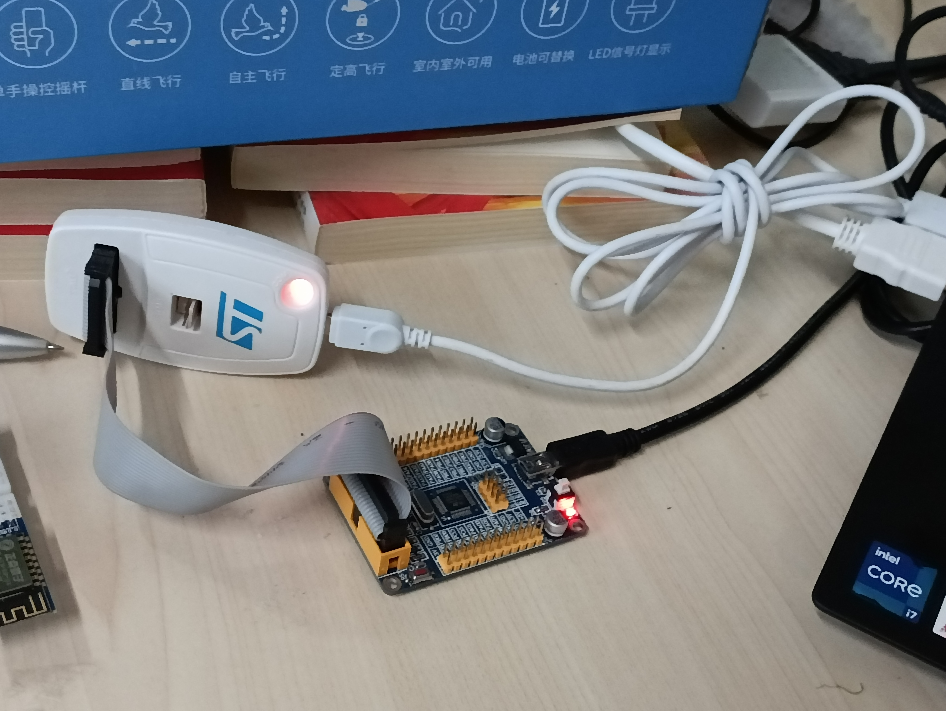

STM32F103C8T6
Started experiments with servo https://www.youtube.com/watch?v=AjN58ceQaF4, it worked using https://www.youtube.com/watch?v=TAAaE7cHdMQ.

Started research on wireless communication. Bluetooth can be an option https://www.youtube.com/watch?v=RPU2wzfewY8 as well as ESP8266. I did some unsuccsesfull tests with a ESP8266 that I found in the lab. Gathered a good sample of tutorials for ESP8266 to try .
Videos:
https://www.youtube.com/watch?v=hdkGWKNdzSs
https://www.youtube.com/watch?v=W22WsNbMNOM
https://www.youtube.com/watch?v=bPDCmvywusM
https://www.youtube.com/watch?v=FRAlFSaYb8c
https://www.youtube.com/watch?v=MG-5Ct_rCZQ
https://www.youtube.com/watch?v=LS7owD8C_tI

Tutorials
https://circuitdigest.com/microcontroller-projects/interfacing-esp8266-with-stm32f103c8-stm32-to-create-a-webserver
https://lupyuen.github.io/articles/connect-stm32-blue-pill-to-esp8266-with-apache-mynewt
https://github.com/smart-storm/storm-iot-node
https://circuitdigest.com/microcontroller-projects/interfacing-esp8266-with-stm32f103c8-stm32-to-create-a-webserver
https://controllerstech.com/esp8266-webserver-using-stm32-hal/

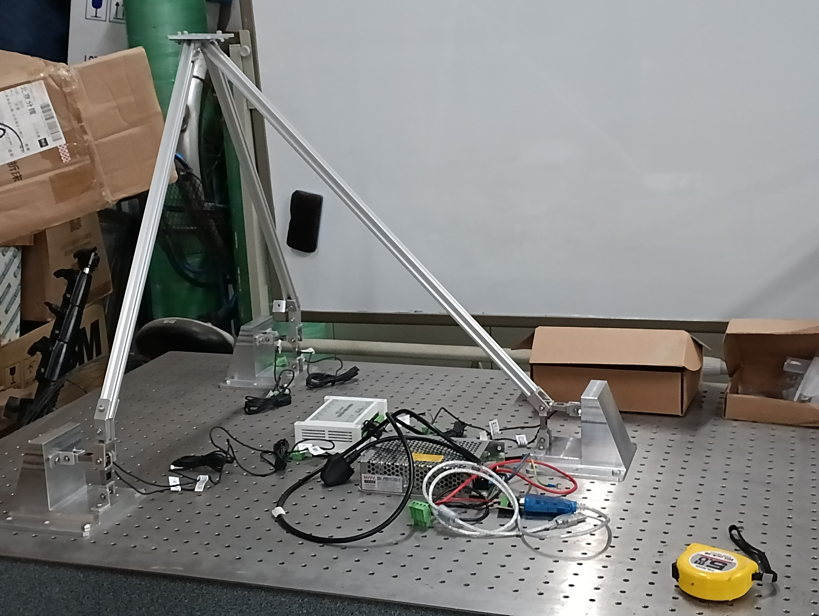
Note: I am now convinced that using STM32 is the best idea, it is much more powerful and professional. It is also what Dr. Li uses, so it is a good idea to use the same software, also the measurements from the test will be achieved by a hardware (which was installed yesterday by Dr. Li) so the main tasks right now are how to command the stm32 wirelessly and how to obtain the data from Dr Lis data logger in an automatic way to python so that the GA can work without the need of constant intervention. Everything is starting to look much more “scientific” using the hardware provided by Dr. Lin, compared to my naive initial idea of using Arduino…

And….. Baaam! Surprise task. Dr. Li asked me if I can help him put the membrane on the Batbot, as Prof. Zhao said that he wanted to present my idea in his international conference in Hong Kong ( !!!!) . So goodbye salsa and KTV hello preparing presentation until 2am(:. Interestingly, I enjoyed it. It is nice to see an idea starting to get in form, and if Prof. Zhao thought it was good enough to present it, then I will try to do it as best and quick as possible.

https://www.youtube.com/watch?v=lP0ehhbb1eQ

2023.03.26

Last week I was sick, it started on the evening of Sunday and I spent in bed until wednesday, from there I had two homeworks with approaching deathlines so I had to spend my time doing that.
The advancements made on the project this week could be summarized in a better and deeper understanding of the esp8226 module, I can now program it using AT commands from the arduino serial monitor. I spent a lot of time trying to connect the esp8226 to the STM32 unsuccesfully, on the coming days I plan to follow a detailed tutorial that aims to solve this, if that is not succesfull I plan to configure the ESP8266 independently to send strings of data when a get request arrives and learn how to process the string in STM32 using serial communication.
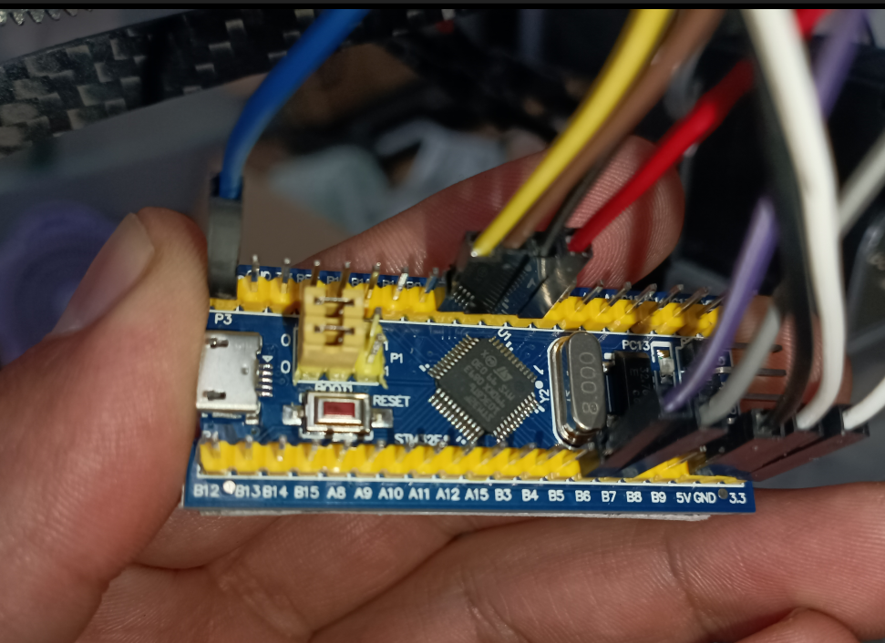
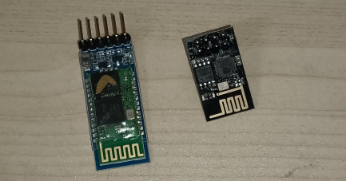
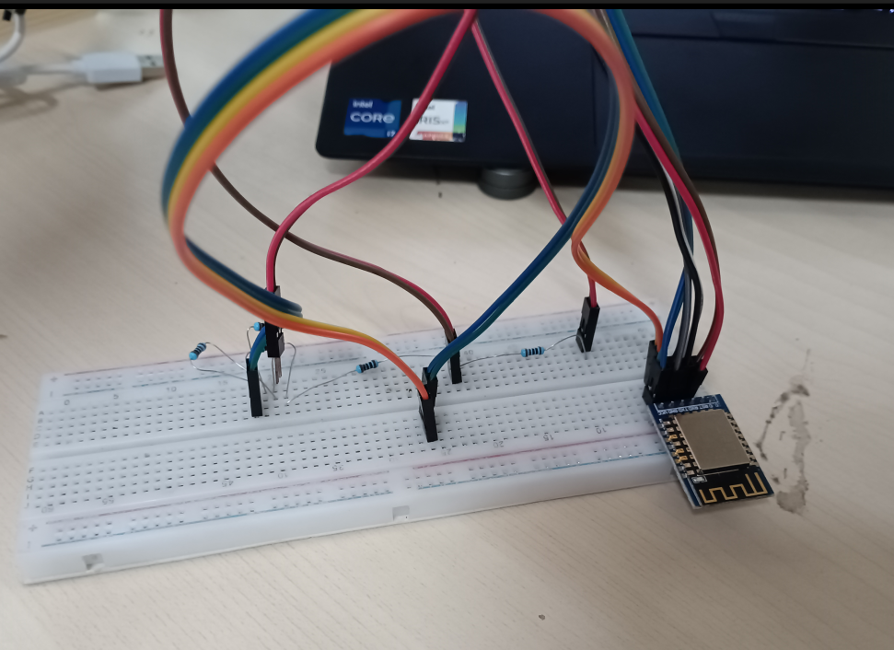

Today I prepared a presentations of advancements and future steps for tomorrow.

2023.03.27

Connecting the ESP8266 is proving to be more challenging than expected, I think I first need to better understand how does the serial communication of the STM32 works, as without it I am not able to know if the EsP8266 is actually working, so my next steps are based on understanding and testing serial communication between STM32 and the computer. UPDATE: I ended up burning something and now I ordered a new arduino. I have to be more careful this components are not idiot proof, I fear I might have burned some from the beginning and spent hours trying to make a burned component work.

2023.03.28

I used the NODEMCU to directly command the ESP8266 in AT mode. This tutorial is the one that should be followed to make AT commands work.
https://electronza.com/esp8266-at-mode-webserver-tutorial/

The pinout it quite simple (keep in mind that NodeMCU uses 3.3V) if you use arduino you might need to do some electro magic to reduce input voltage. (https://learn.circuit.rocks/using-at-commands-on-the-esp8266) I am sure I burned some of my first ESP8266, lesson learned.

ESP8266-NodeMCU
gnd-gnd
tx-tx
rx-rx
3,3-3.3
ch_pd/en-3.3

Baud rate:115200

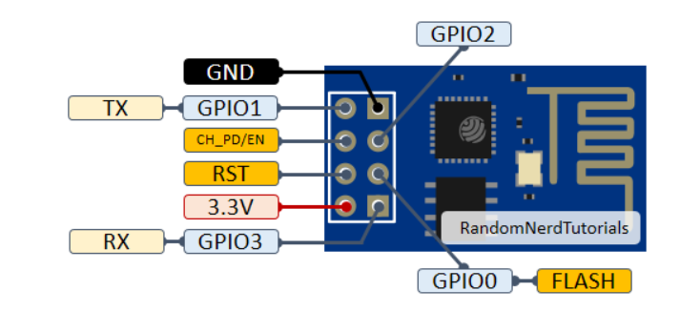

HTTP/1.1 200 OK
Content-Type: text/html
Connection: close
(here we might add additional info in the future to send back after request, but not a priority now)
Summary ESP8266 for future reference:
Every time you start ESP8266 we need to initialize it as follows:

AT+RST
AT+CWMODE=1
AT+CWJAP="batbot","12345678"
AT+CIFSR
AT+CIPMUX=1
AT+CIPSERVER=1,80

then we can send Get commands with python, that need to be responded from the esp8266 with:
AT+CIPSEND=0,55

HTTP/1.1 200 OK
Content-Type: text/html
Connection: close
AT+CIPCLOSE=0

Today I gained a much better understanding of the ESP8266, which was explained in the last part. I saw a series of tutorial for STM32 (https://www.youtube.com/watch?v=hYYRfhhvTYo&list=PLr0mEvO7yBe6Ga7wJpRTZpxAYSvgWY0A-&index=1) to obtain a even deeper understanding, as at the moment even though I can understand the ESP8266, it is not possible for me to create a connection with the STM32. I think that understanding UART and serial communication from scratch might be usefull. This video provided a good insight https://www.youtube.com/watch?v=JWOV4j5fCS4, can be a great starting point.

2023.03.29

Ok.. so after a couple slow paced days, I start to see advancement. I was finally able to proof that the stm32 is sending and receiving data. Doing the serial communication was to complicated and I still haven’t figured out how to connect it. All the tutorials that I have seen say that UART2 is by default connected to the usb exit of the board, never the less when I connect the USB to the computer it is not recognize, I guess it might have something to do with the fact that I am directly coding on the chip and that my STM32 project settings are done in the chip and not in the board. I solved this problem by connecting by enabling UART1 (RCC: Crystal, Usart in pic)

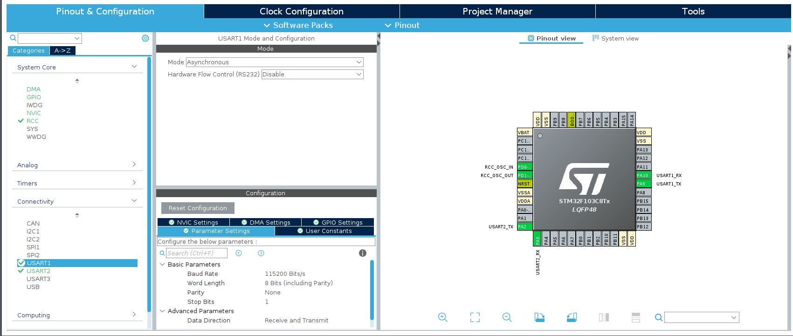
Then I connectedt the tx and rx to the tx and rx pin of the NodeMCU and used the serial monitor of the arduino to successfully send and receive data from the STM32, I sent a hello world message to the arduino and I could see the data sent from the serial monitor in the debuger mode of STM32. With this I can start with the real experiments, my following idea is to configure the ESP8266 using the arduino serial monitor (as I did yesterday) and then when it is configured just change the connection to send data to the STM32, from the debugger I will be able to see what is being received and start working to filter the relevant data from the get requests. The next step would be to slowly work my way to not depend on the arduino, but this will be accomplished step by step.

The problem arouse, that I was only able to send one byte of data to the stm32, after several tutorials this one (https://www.youtube.com/watch?v=Bo6MC5A8uTE&list=PLfIJKC1ud8gjhc4HiqVXUzcVq4iL5MqTz) was the only one that actually worked. With this, I receive all the string that I send from the arduino, instead of only the first char. The final test was to connect the ESP8266 to the arduino but connect the tx of the esp8266 to the rx of the stm32 and I was able to use ArduinosIDE to send At command and read the response from the ESP8266 debuger… alfin cgdm!!

2023.03.30

I achieved send AT commands form the arduino and the responses to be read from the stm32. The buffer was not being refreshed but only overwritten, leaving data in the buffer if the new data was shorter than the older, this was repaired. I was even able to obtain the GET commands from the ESP8266, there was some funny error when commanding AT+RST, somehow the uart_received gets a lot of data simultanously and then stops working. This was provisionally solved by not using the AT+RST command, the rest work fine. The next step before investing to much time is to use the current state with the HC05 (from which the new ones arrived today) If Hc05 is easy to programm this may eliminate the hurdle of needing to initialize th ESP826 with AT and also sending close commands to the get request. I believe with the HC05 I will be able to simply get raw data and work with that.

2023.03.31

I experimentes a for a while with the HC05. I proved to be also not as straight forward, I was able to send and receive data from the phone, but when connecting the tx and rx pins to the serial monitor I got large amount or rubbish data, I think that it could be solved, but I rather take advantage of the time invested learning ESP8266 and continue trying to use it, as now it looks more promising than ever.

I completed the whole cycle of stm32 Esp8266, I connected the STm32 to the esp using a voltage reductor for the rx pin of the esp8266 and wrote the code to initialize the esp8266 wifi config and also to close the connection when a GET request arrives. I also implemented a simple filter fucntion that extracts the values that are between $ and ! And saves them in an array called interesting. Once I know more about the exact working of the batbot I can adapt the array “interesting” to get relevant values for the experiments. The connections and commands were obtained from the tutorials mentioned on day 23.03.28. (after each AT command a \r\n is added in the stm32 code).
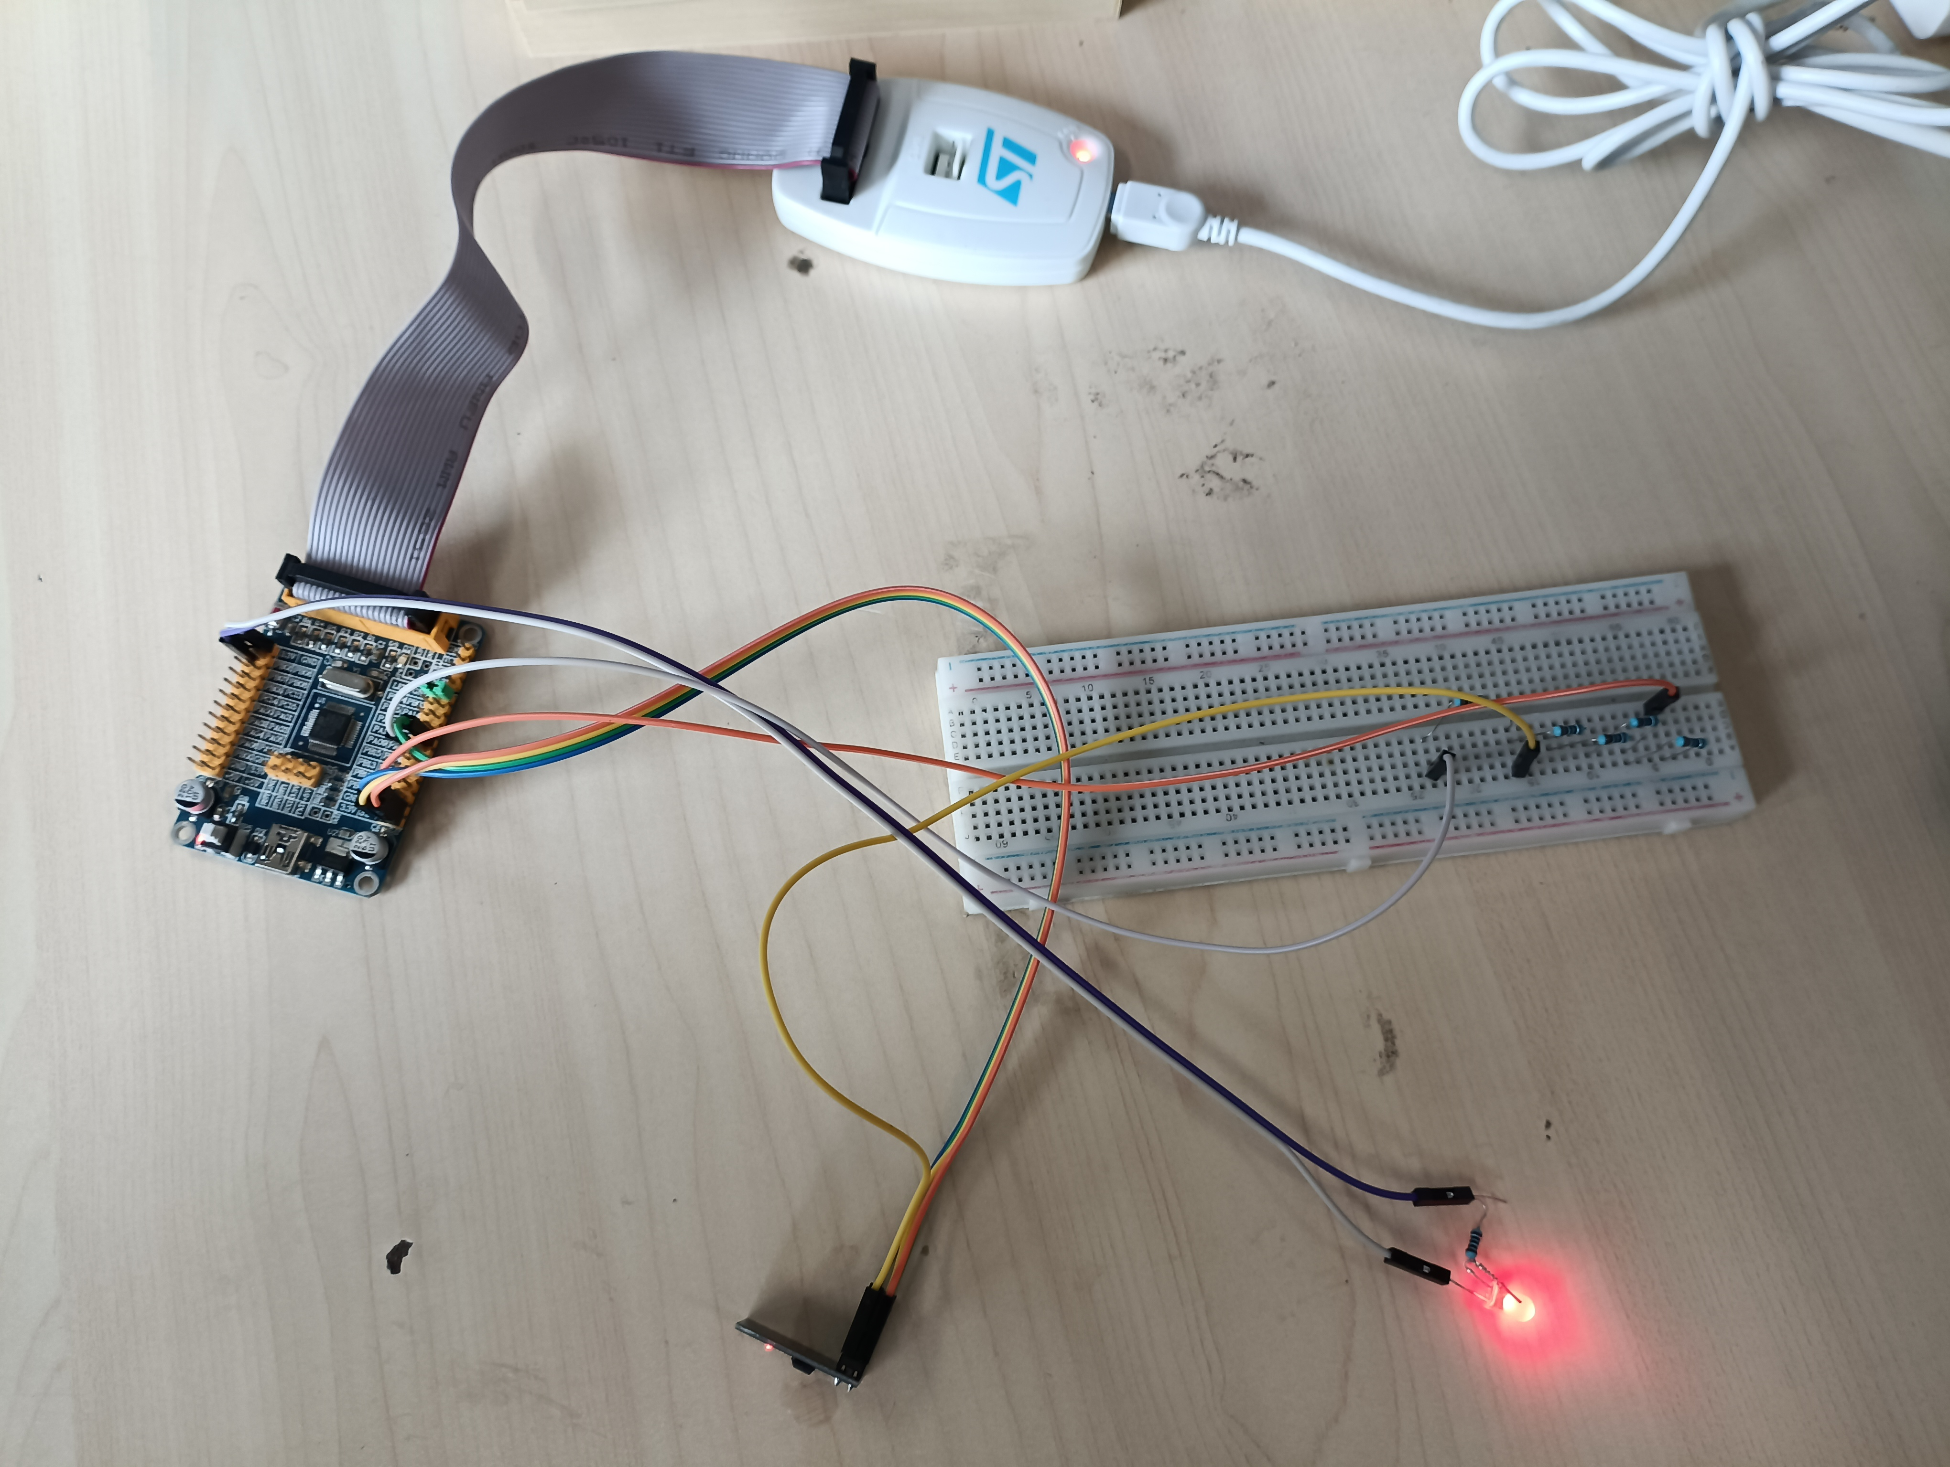
2023.04.01-02

Once the computer stm32 communication was achieved I decided that the most urgent next step is to obtain data from the sensors. Dr. Li has connected everything for the test bench and achieved connection with his computer. Unfortunately the software he uses is only for windows, I spent some time researching how to install windows on my computer but before doing that, I decided to try to make it work with Linux. For this I downloaded Labview instead, I saw a lot of tutorials were I also realized that using labview it would be very easy to get the data to python, the only problem that I face at the moment is that the data logger instrument is the BSQ-JNP8 (instead of the more known National Instrument). Therefore I have spent these days trying to connect the data logger with labview, for this apparently I need to install some drivers. I tried installing the driver NI-DAQ™mx
but was at first glance unsuccessful, never the less it was just a quick try and more has to be tried.

2023.04.03

I prepared the weekly presentation and presented it. Not so much attention was given and the feedback was just to continue with my plan, not sure if good or bad. Spent the rest of the day doing homework.

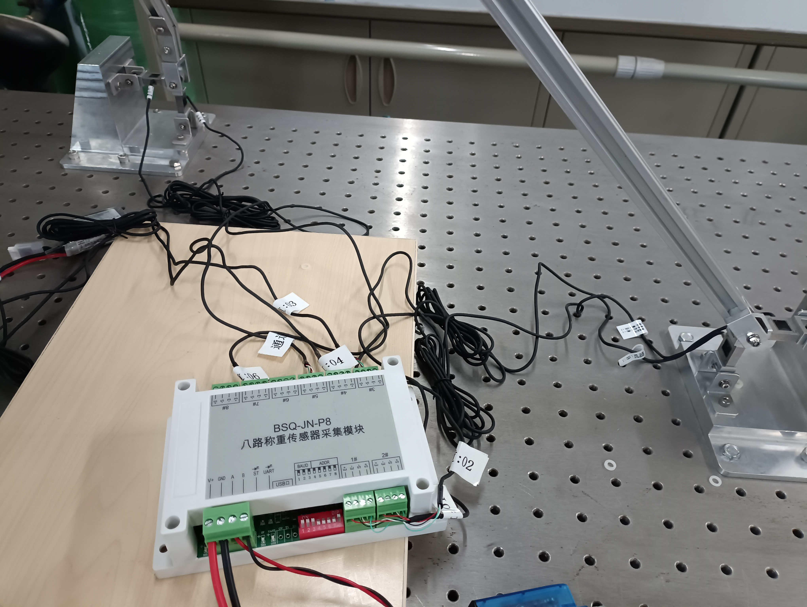

2023.04.04-07

The Professor told me he is a research associate of a journal and we told me there was an interesting paper that he would like me to give a look at. Before I knew it I was register as a reviewer of his journal. The paper he gave me was about controlling a model of a hovercraft using a PD Fuzzy like controller, and using an algorithm to optimize the PD parameters of the fuzzy like controller. The optimization algorithm was the bacterial foraging optimization enhanced using the particle swam optimization in a specific step of the bacterial foraging algorithm.
I spent a day at first trying to understand the algorithm, I had to read some of their referenced papers to get familiar with the topic. I found the concept of biomimic algorithm very interesting and could consider it for a future possible path for me. I particularly learned about the particle swarm optimization, bacterial foraging strategy and pd like fuzzy controllers. Then I was able to understand the paper, then I made a first corrections and comments based on what I know (following the professors advice). Once I was finished I showed it to the professor and Dr. Li, the professor was very excited with my comments and gave me a very positive feed back. He then offered me to give a talk to his undergraduate student about paper reviewing and correct scientific writing (ja! La mamaaáh). Then I made a deeper research on correct scientific paper, corrected some parts of my review based on my newly gained knowledge and submitted my review to the journal.

2023.04.08-09

I got back to trying to connect my computer with the data acquisition instrument (DAQ). I am still in the first general research face of the problem solution. I am watching tutorials and seeing if it is possible to connect the DAQ with python directly.

2023.04.10

Tried for a while to correctly install Labview and the DAQmx drivers, I installed and reinstalled and uninstalled several times as it gave no results ( the DAQ assitant was not showing in Labview). Then I tried skipping Labview and trying directly with a program provided by the drivers (NI Hardware …) I then tried to directly connect to the module using python. This search oblige me to better understand the BSQ-JN-P8 and realize that it uses serial communication, for this I tried to connect it to python. I had just managed to make a connection, the next step will be how to retrive data (if possible). For now here is how I made connection:

- I first needed to find the path of the DAQ, this is achieved using the command:
sudo dmesg | grep FTDI in the terminal

- then I used the following code with the found port:

####################################
import time
import serial

ser = serial.Serial(
port='/dev/ttyUSB0',
baudrate=9600,
parity=serial.PARITY_ODD,
stopbits=serial.STOPBITS_TWO,
bytesize=serial.SEVENBITS
)

ser.isOpen()
#####################################

After experimenting with pyserial using arduinos, and also learning how to use the serial terminal from the computer I followed the question posted in: https://stackoverflow.com/questions/74935263/can-t-read-register-of-modbus-using-python-via-485?rq=4

and with the code:
import serial # import the module
ComPort = serial.Serial('/dev/ttyUSB0') # open COM4
ComPort.baudrate = 115200 # set Baud rate to 9600
ComPort.bytesize = 8 # Number of data bits = 8
ComPort.parity = 'N' # No parity
ComPort.stopbits = 1 # Number of Stop bits = 1
ComPort.write(b'\x01\x03\x00\x00\x00\x02\xC4\x0B')
ComPort.read()
print(ComPort.read(), 'a')
ComPort.close()
I had my first communication with the BSQ-JN-P8 (DAQ), so as I had supposed, the DAQ awaits for a specific command to return any information.

2023.04.11-12

I spent the last 2 days better understanding how the modbus protocol works. I saw several videos and tried learning how to use the python module pymodbus. Unfortunately, after I while trying I was not able to make the module work, I believe that with a better understanding, the module should be the easiest way to communicate with the DAQ. As I was already able to successfully communicate with the DAQ directly using serial, I decided to instead understand from scratch how does the communication with the DAQ work and create a python implementation of my own to get my data. For this the documentation of the DAQ (provided by Dr. Li) was incredibly useful. After a couple videos and many attempts I got a hold of how it worked and I the end I found myself manually converting bytes to floats (those informatics classes were not so useless after all). So at the end I was able to obtain the data from the sensors, convert it and save it in a data frame.

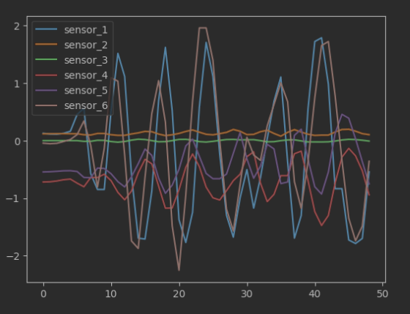

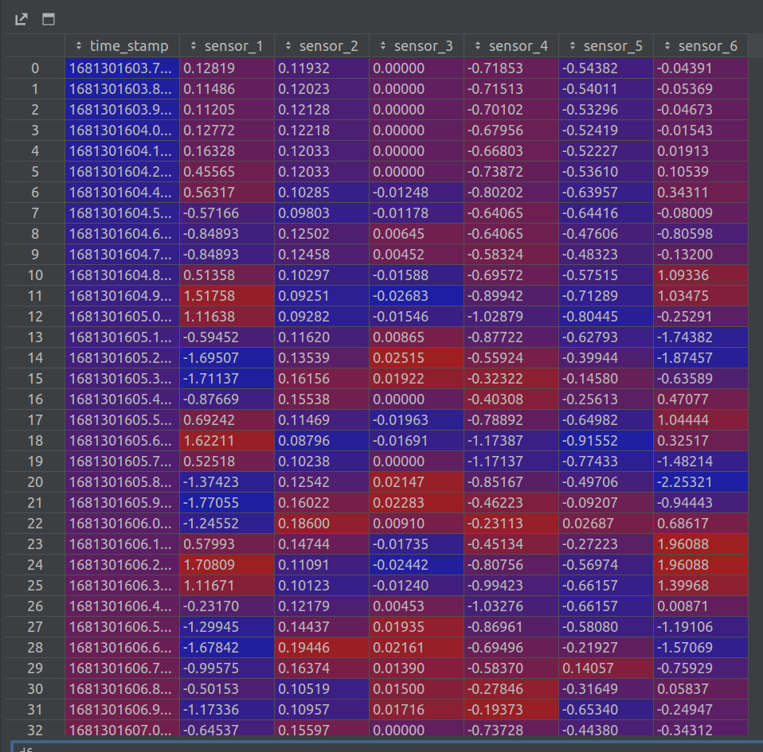

This is the initial phase, some refinements must still be done.

2023.04.13

I solved a problem regarding correct reading of measurements. Before, when my sensor reading frequency was too high, some measurements had less bytes and the next ones had more, this was solved by fixing the amount of bytes to read (to 37). This allows me to obtain the max amount of possible measurements. I started experimenting with calibration on the sensors, I realized that there is what I believe to be a small constant linear drift, more experimentation needs to be done to understand the reading on the sensor in the neutral position. I started to try to understand how to convert the sensor readings to force, the Professor recommended me to directly work with the sensor measurements instead of calculating the force. If this is to be done, I believe there must be some sort of weighting to the sensors, as I believe that there might be some that have smaller values that are more relevant to the representation of hovering that others.

2023.04.14

Today I would like to focus on the calibration problem of the sensors. I think that throughout time there is a constant drift of the measurements, so I made several experiments. I had to be careful because I was already starting to tackle several issues at the same time, so I came back to the original problematic; drift and hysteresis in the measurements. So I did the following experiments whose analysis can be found in detail in drift_analysis.ipynb.

